

SMT - SECS/GEM
User manual

1.0.0.6

2022/05/17

大量科技股份有限公司 TALIANG TECHNOLOGY
桃園市八德區友聯街49號 No. 49, Youlian St., Bade Dist., Taoyuan City 334009, Taiwan
TEL : (03)3686368 / FAX : (03)3685811

目錄
Install
SECS/GEM Driver & Dongle Install 6
User Interface
SECS/GEM Interface - State 7
SECS/GEM Interface - Default SubState 10
SECS/GEM Interface - Manual SV,DV,EC 11
SECS/GEM Interface - Manual Alarm 14
SECS/GEM Interface - Manual Event 15
SECS/GEM Interface - Manual Spooling 16
SECS/GEM Interface - Manual Terminal 17
SECS/GEM Interface - Manual PP 18
Config Interface 19
SYSTEM ID
SYSTEM SV 20
SYSTEM DV 22
SYSTEM EC 23
SYSTEM EVENT 25
EQUIPMENT ID
EQUIPMENT SV 26
EQUIPMENT DV 27
EQUIPMENT EVENT 28
EQUIPMENT ALARM 29
SECS/GEM REPORT
EVENT REPORT LINK 36
SECS-II Message LIST
Message List (H -> E) 38
Message List (E -> H) 39
SECS-II Message Example
Stream 1 : Equipment Status
S1F1 : Are You There Request (H -> E) 40
S1F2 : On Line Data (E -> H) 40
S1F3 : Selected Equipment Status Request (H -> E) 41
S1F4 : Selected Equipment Status Data (E -> H) 41
S1F11 : Status Variable Name List Request (H -> E) 42
S1F12 : Status Variable name List Reply (E -> H) 42
S1F13 : Establish Communications Request (H -> E) 43
S1F14 : Establish Communications Request Acknowledge (E -> H) 43
S1F15 : Request Off-Line (H -> E) 44
S1F16 : Off-Line Acknowledge (E -> H) 44
S1F17 : Request On-Line (H -> E) 45
S1F18 : On-Line Acknowledge (E -> H) 45
Stream 2 : Equipment Control and Diagnostics
S2F13 : Equipment Constant Request (H -> E) 46
S2F14 : Equipment Constant Data (E -> H) 46
S2F15 : New Equipment Constant Send (H -> E) 47
S2F16 : New Equipment Constant Acknowledge (E -> H) 47
S2F17 : Date and Time Request (H -> E) 48
S2F18 : Date and Time Data (E -> H) 48
S2F23 : Trace Initialize Send (H -> E) 49
S2F24 : Trace Initialize Acknowledge (E -> H) 49
S2F25 : Loop Back Diagnosis Request (H -> E) 50
S2F26 : Loop Back Diagnosis Reply (E -> H) 50
S2F29 : Equipment Constant Name List Request (H -> E) 51
S2F30 : Equipment Constant Name List Reply (E -> H) 51
S2F31 : Date and Time Send (H -> E) 52
S2F32 : Date and Time Acknowledge (E -> H) 52
S2F33 : Define Report (H -> E) 53
S2F34 : Define-Report Acknowledge (E -> H) 53
S2F35 : Link Event Report (H -> E) 54
S2F36 : Link Event Report Acknowledge (E -> H) 54
S2F37 : Enable/Disable Event Report (H -> E) 55
S2F38 : Enable/Disable Event Report Acknowledge (E -> H) 55
S2F41 : Remote Command Send (H -> E) 56
S2F42 : Remote Command Acknowledge (E -> H) 57
Stream 5 : Alarm Handling
S5F1 : Alarm Report Send (E -> H) 58
S5F2 : Alarm Report Acknowledge (H -> E) 58
S5F3 : Enable/Disable Alarm Send (H -> E) 59
S5F4 : Enable/Disable Alarm Acknowledge (E -> H) 59
S5F5 : List Alarms Request (H -> E) 60
S5F6 : List Alarm Data (E -> H) 60
S5F7 : List Enabled Alarms Request (H -> E) 61
S5F8 : List Enabled Alarm Data (E -> H) 61
Stream 6 : Data Collection
S6F1 : Trace Data Send (E -> H) 62
S6F2 : Trace Data Acknowledge (H -> E) 62
S6F11 : Event Report Send (E -> H) 63
S6F12 : Event Report Acknowledge (H -> E) 63
S6F15 : Event Report Request (H -> E) 64
S6F16 : Event Report Data (E -> H) 64
S6F19 : Individual Report Request (H -> E) 65
S6F20 : Individual Report Data (E -> H) 65
Stream 7 : Process Program Managed
S7F1 : Process Program Load Inquire (H -> E) 66
S7F2 : Process Program Load Grant (E -> H) 66
S7F5 : Process Program Request (H -> E) 67
S7F6 : Process Program Data (E -> H) 67
S7F19 : Current Process Program Dir. Request (H -> E) 68
S7F20 : List Process Program Data (E -> H) 68
S7F25 : Formatted Process Program Request (H -> E) 69
S7F26 : Formatted Process Program Data (E -> H) 69
Stream 9 : System Errors
S9F7 : llegal Data (E -> H) 70
S9F9 : Trace Data Send (E -> H) 70
Stream 10 : Terminal Services
S10F1 : Terminal Request (E -> H) 71
S10F2 : Terminal Request Acknowledge (H -> E) 71
S10F3 : Terminal Display (H -> E) 72
S10F4 : Terminal Display Acknowledge (E -> H) 72
SMT-SECS/GEM Infomation
PPBODY 73
Magazine MoveIn Log 75
Boat MoveIn Log 76
PassBoat MoveOut Log 77
NGBoat MoveOut Log 78
EmptyBoat Release Log 79
Pass1Magazine MoveIn Log 80
Pass2Magazine MoveIn Log 81
NGMagazine MoveIn Log 82
EmptyMagazine MoveIn Log 83
Pass1Magazine MoveOut Log 84
Pass2Magazine MoveOut Log 85
NGMagazine MoveIn Log 86
Boat Assing NGBoat Log 87
UI Lock Command Log 88
Equipment Operational Command Log 90
Equipment EndLot Command Log 92
Equipment StartRun Check Log 93

SECS/GEM Driver & Dongle Install

STEP1 :  Install HASPUserSetup.exe | 
STEP2 :  Insert SECS/GEM Dongle to Computer’s USB port | 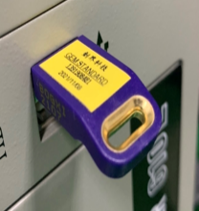

※If the installation fails or the USB cannot be read, the message box will pop up as shown below.

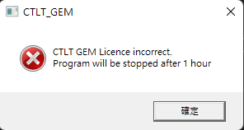

SECS/GEM Interface - State
SECS Connection state
Communicating state
Enable/Disable Comm
Display of current control status
Status toggle field
Messagebox

GEM Initial result show

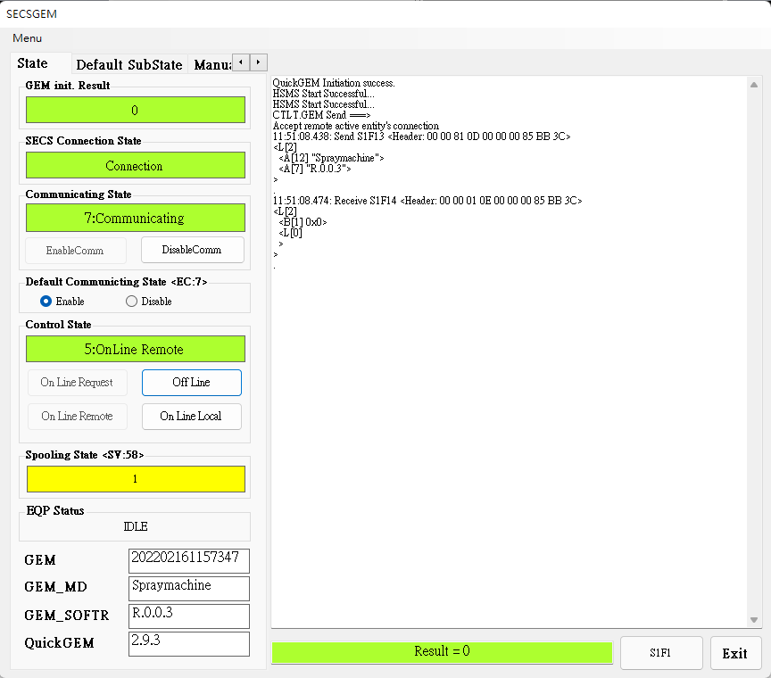
GEM Clock
GEM MODEL Name
GEM Software Version
QuickGEM Software Version

EQ Status show
Spooling State show
Are you there command
Last command result

EnableComm : Start Communication
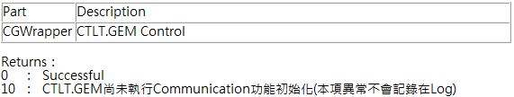
------------------------------------------------------------------------------------
DisableComm : Stop Communication
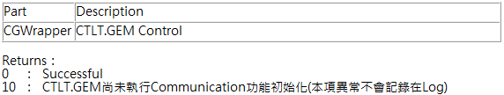
------------------------------------------------------------------------------------
On Line Request : Send the request to connect with the remote On Line
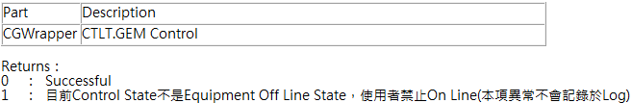
------------------------------------------------------------------------------------
Off Line : Send the request to disconnect with the remote On Line
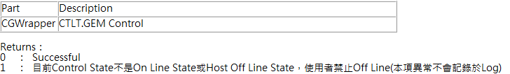

On Line Remote : Switch to remote control status
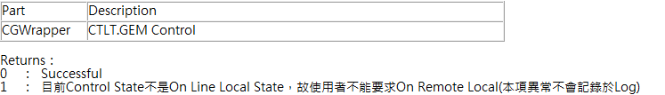
------------------------------------------------------------------------------------
On Line Local : Switch to local control status
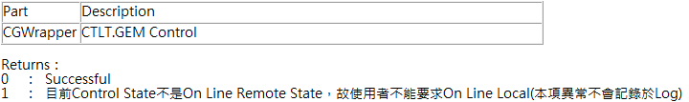

SECS/GEM Interface – Default Substate
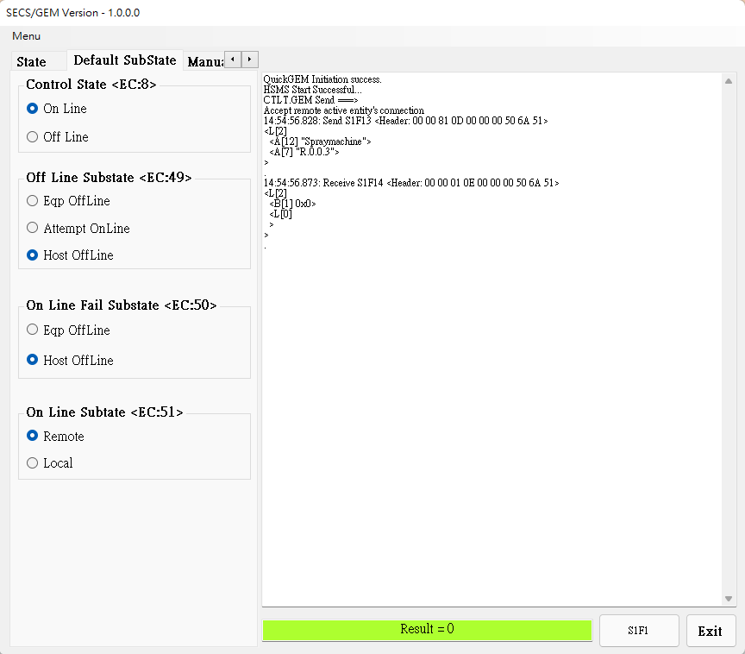
Switch EC:8, EC:49, EC:50, EC:51 ‘s sub state, See [System EC page (p.23) ] for details

SECS/GEM Interface – Manual SV,DV,EC
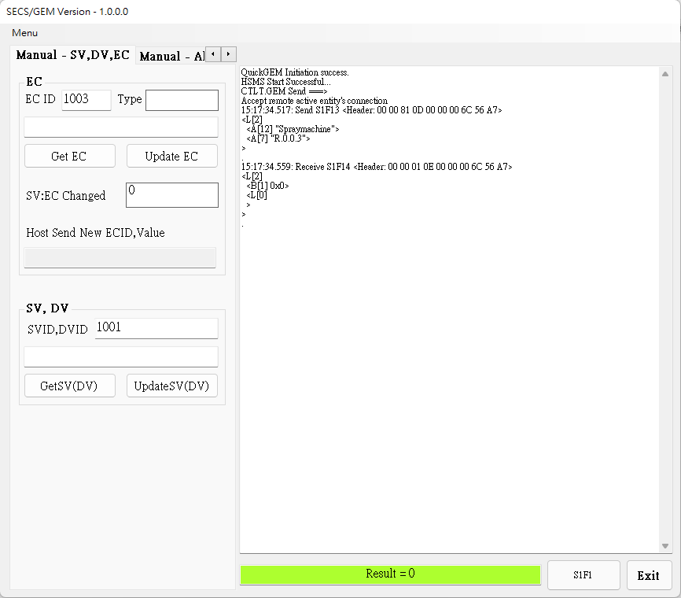
Update EC : Update specified Equipment Constant(EC) value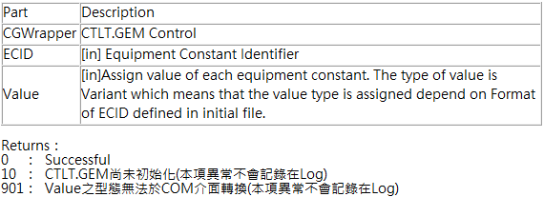

Update SV(DV) : Update specified Status Variable(SV) and Data Value(DV) value
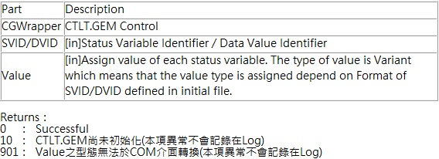
------------------------------------------------------------------------------------
GetEC : Load specified Equipment Constant value
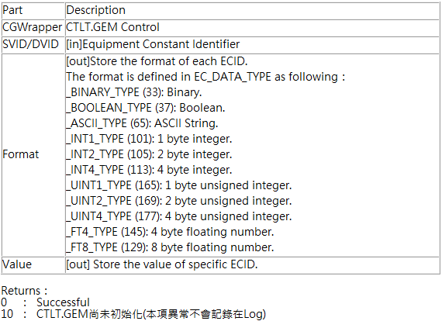

GetSV(DV) : Load specified Status Variable(SV) and Data Value(DV) value
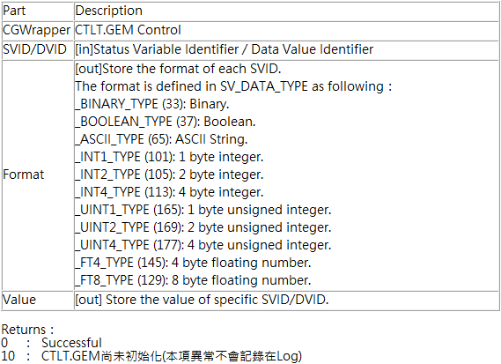

SECS/GEM Interface – Alarm
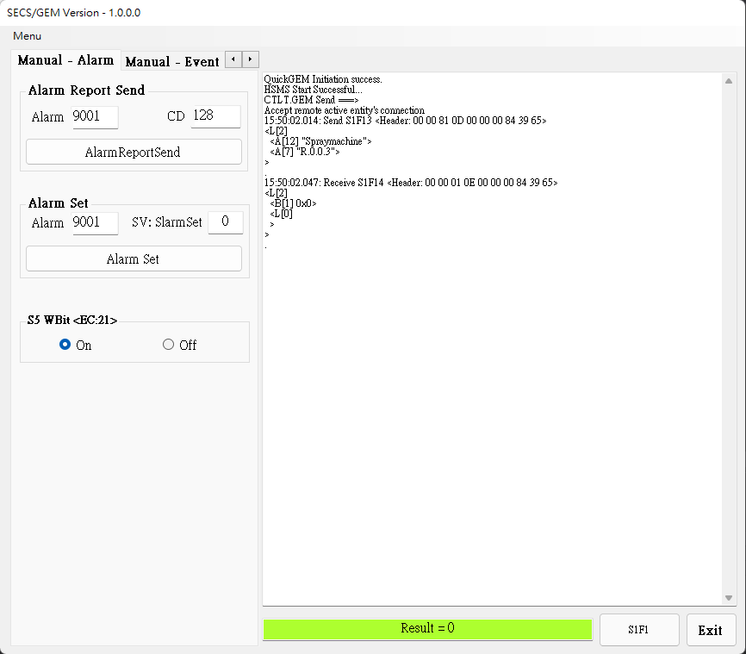
AlarmReportSend : Based on specified Alarm ID send alarm message
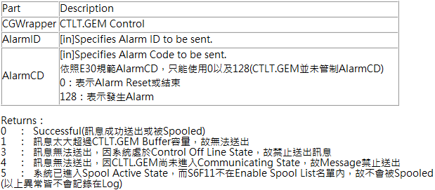
------------------------------------------------------------------------------------
S5 WBit <EC:21> : See [System EC page (p.23) ] for details
SECS/GEM Interface – Event
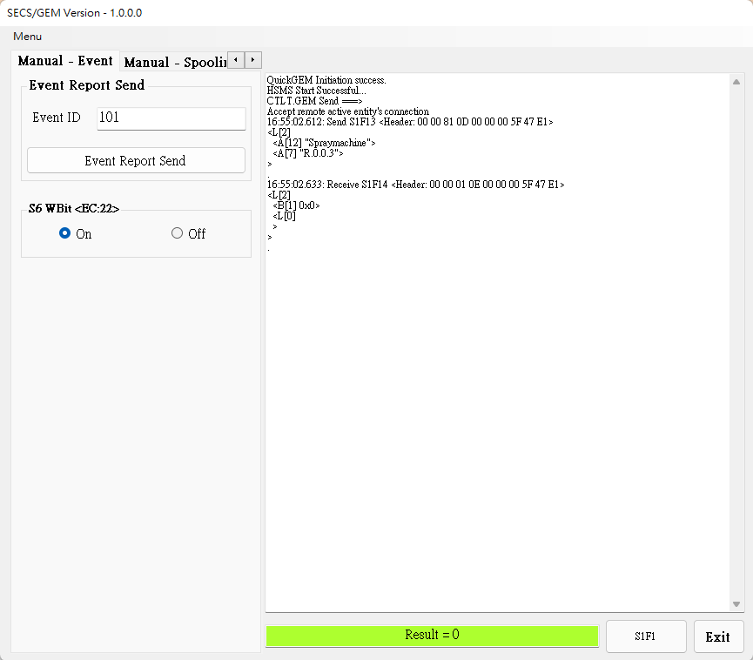
EventReportSend : Based on specified Event ID send event message
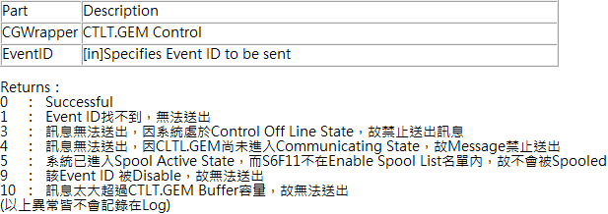
------------------------------------------------------------------------------------
S6 WBit <EC:22> : See [System EC page (p.23) ] for details
SECS/GEM Interface – Spooling
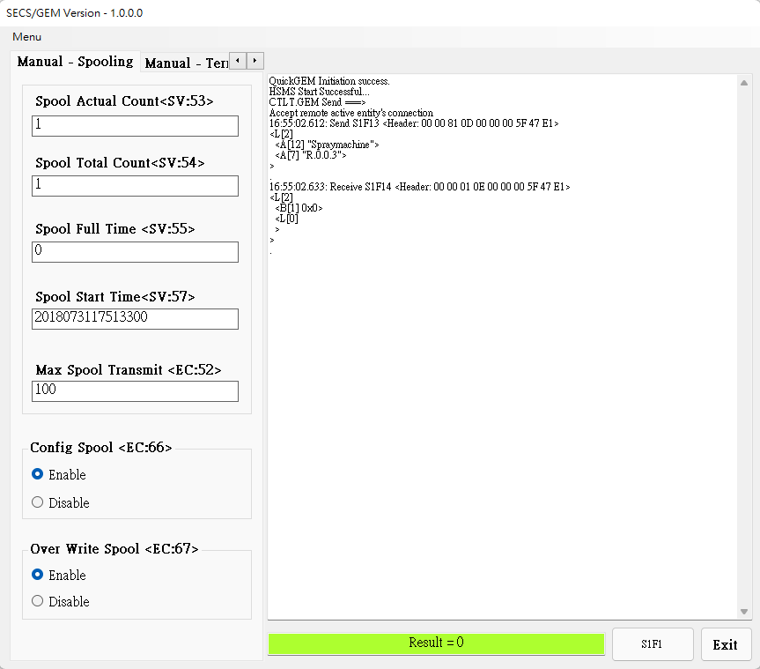
Display SV:53, SV:54, SV:55, SV:57 current value, See [System SV page (p.20) ] for details

Display EC:52current value, See [System EC page (p.23) ] for details

Open/Close EC66, EC67 enable state, See [System EC page (p.23) ] for details

SECS/GEM Interface – Terminal
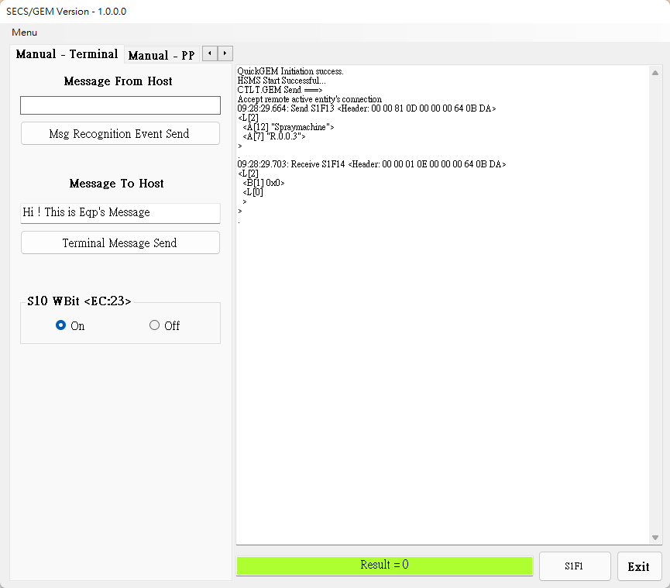
Msg Recognition Event Send: Send terminal message
------------------------------------------------------------------------------------
Terminal Message Send: Send terminal message
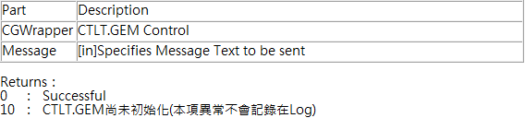
------------------------------------------------------------------------------------
S10 WBit <EC:23> : See [System EC page (p.23) ] for details
SECS/GEM Interface – PP
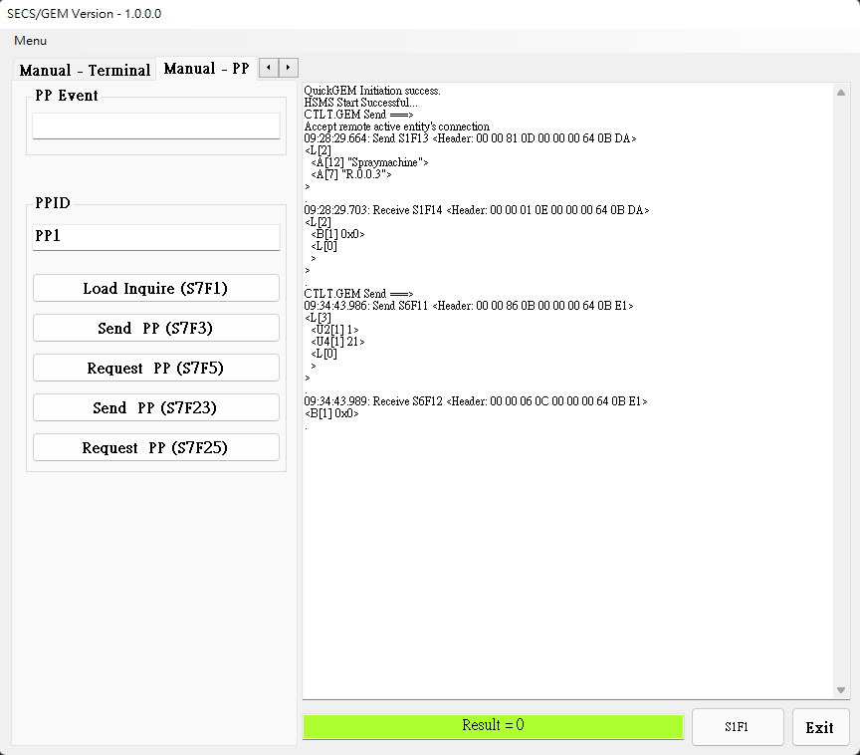
Function specified by excute CmdID
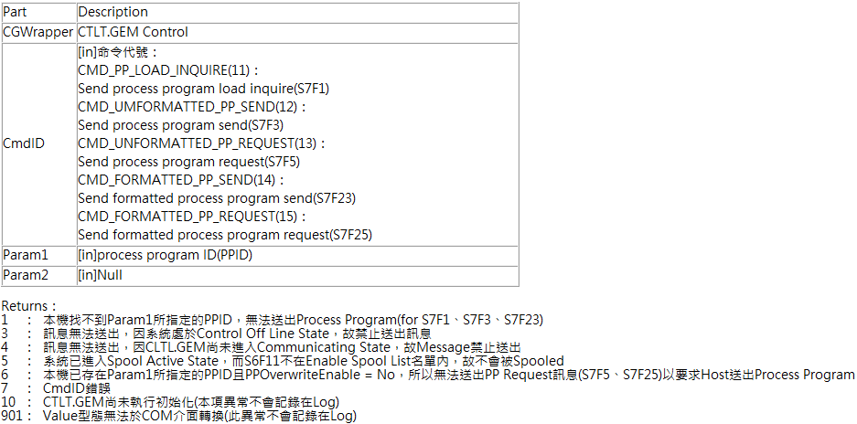
Config Interface
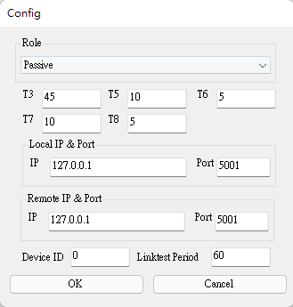
Role : Set the machine as the active side (Host) or the passive side (Equipment)
T3 : Set the time for the sender to wait for the receiver to return a message after sending the data message
T5 : After the TCP/IP connection is set to fail, the active side needs to wait for T5 time before reconnecting
T6 : Set the time for the sender to wait for the receiver to return a message after sending a control message
T7 : Set the time to wait to enter Selected Stats after entering Connected Stats
T8 : Set the maximum time interval allowed between characters in the message when the receiver receives the message
Local IP & Port : Set local IP & Port
Remote IP & Port : Set remote IP & Port
Device ID : Set Device ID
Linktest Period : Set the interval for sending test messages periodically (limited by T6)
System SV

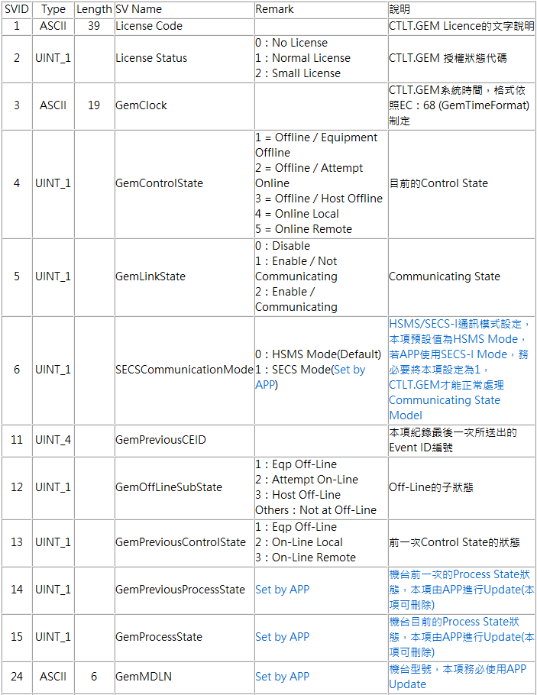

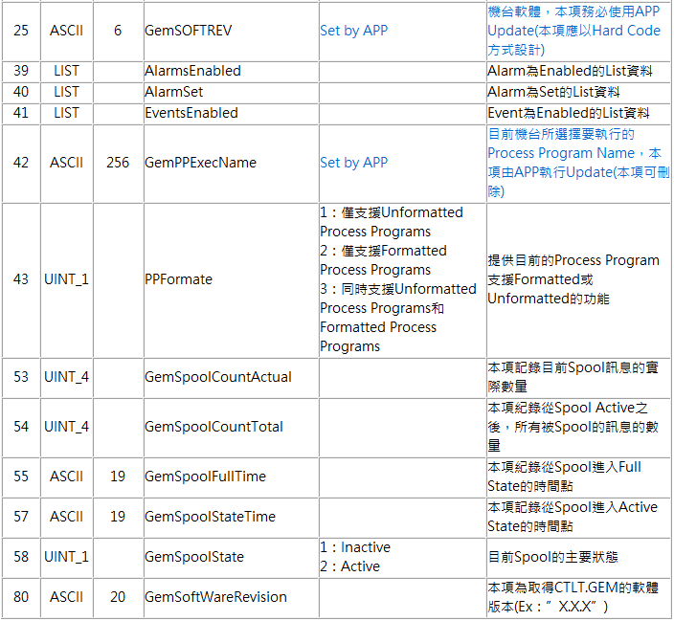

System DV

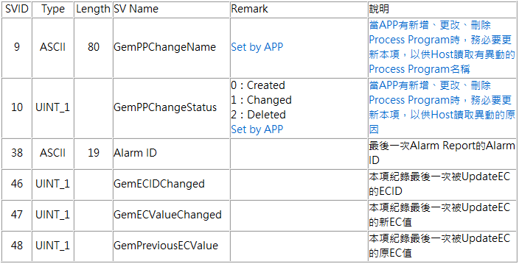

System EC

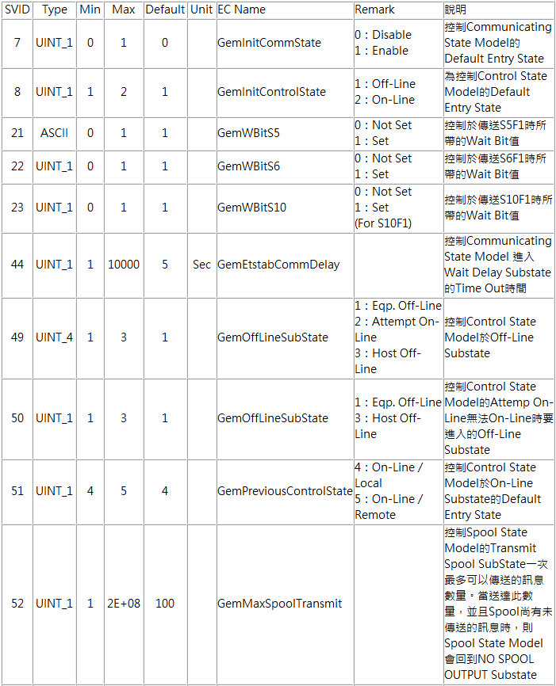

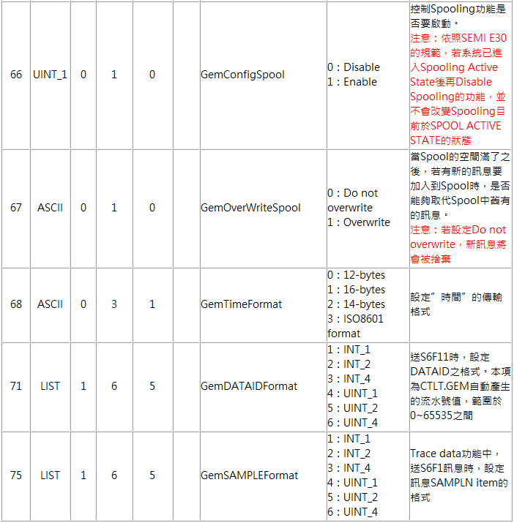

System Event

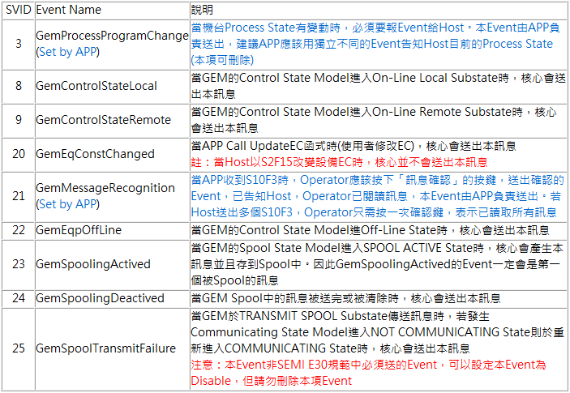

Equpiment SV

ID | TYPE | Lenght | NAME | Definition
1001 | ASCII | 1000 | MagazineIDCheck | 入料端MagazineID確認
1002 | ASCII | 1000 | BoatBarcodeCheck | 入料端BoatID確認
1003 | ASCII | 1000 | Pass1MagazineIDCheck | 出料端Pass1MagazineID確認
1004 | ASCII | 1000 | Pass2MagazineIDCheck | 出料端Pass2MagazineID確認
1005 | ASCII | 1000 | NGMagazineIDCheck | 出料端NGMagazineID確認
1006 | ASCII | 1000 | EmptyMagazineIDCheck | 出料端EmptyMagazineID確認
1007 | ASCII | 1000 | BoatAssingNGBoatBarcodeCheck | 出料端 空Boat回流登記NGBoat確認
1008 | ASCII | 1000 | UILockCommand | 遠端切換UI鎖定/解鎖狀態指令
1009 | ASCII | 1000 | EquipmentOperationalCommand | 遠端切換設備啟動/停止狀態指令
1010 | ASCII | 1000 | EquipmentEndLotCommand | 遠端控制設備結批指令
1011 | ASCII | 1000 | RemoteActionResult | 遠端指令執行結果
1012 | ASCII | 1000 | EmptyBoatReleaseCheck | 空Boat Release狀態 確認
1013 | ASCII | 1000 | EquipmentStartRunCheck | 設備啟動狀態確認

Equpiment DV

ID | TYPE | Lenght | NAME | Definition
4001 | ASCII | 1000 | LotID | Lot ID
4002 | ASCII | 1000 | MagazineID | 入料端 MagazineID
4003 | ASCII | 1000 | Pass1MagazineID | 出料端 Pass1MagazineID
4004 | ASCII | 1000 | Pass2MagazineID | 出料端 Pass2MagazineID
4005 | ASCII | 1000 | NGMagazineID | 出料端 NGMagazineID
4006 | ASCII | 1000 | EmptyMagazineID | 出料端 EmptyMagazineID
8001 | ASCII | 1000 | BoatBarcode | 入料端Boat條碼
8002 | ASCII | 1000 | PassBoatBarcode | 出料端PassBoat條碼
8003 | ASCII | 1000 | NGBoatBarcode | 出料端NGBoat條碼
8004 | ASCII | 1000 | EmptyBoatBarcode | 出料端 空Boat條碼
8005 | ASCII | 1000 | BoatAssingNGBoatBarcode | 出料端 空Boat回流登記NGBoat條碼
8006 | ASCII | 1000 | RecipeName | 配方名稱
8007 | ASCII | 1000 | Pass1MagazineUnitCount | 出料端 Pass1MagazineID Unit總數
8008 | ASCII | 1000 | Pass2MagazineUnitCount | 出料端 Pass2MagazineID Unit總數
8009 | ASCII | 1000 | NGMagazineUnitCount | 出料端 NGMagazineID Unit總數

Equpiment Event

ID | NAME | Definition
101 | MagazineMoveInEvent | 入料端Magazine MoveIn事件
102 | BoatMoveInEvent | 入料端Boat MoveIn事件
103 | PassBoatMoveOutEvent | 出料端PassBoat MoveOut事件
104 | NGBoatMoveOutEvent | 出料端NGBoat MoveOut事件
105 | EmptyBoatMoveOutEvent | 出料端EmptyBoat MoveOut事件
106 | Pass1MagazineMoveInEvent | 出料端 Pass1Magazine MoveIn事件
107 | Pass2MagazineMoveInEvent | 出料端 Pass2Magazine MoveIn事件
108 | NGMagazineMoveInEvent | 出料端 NGMagazine MoveIn事件
109 | EmptyMagazineMoveInEvent | 出料端EmptyMagazine MoveIn事件
110 | Pass1MagazineMoveOutEvent | 出料端 Pass1Magazine MoveOut事件
111 | Pass2MagazineMoveOutEvent | 出料端 Pass2Magazine MoveOut事件
112 | NGMagazineMoveOutEvent | 出料端 NGMagazine MoveOut事件
113 | BoatAssingNGBoatEvent | 出料端 空Boat回流登記NGBoat事件
114 | RemoteActionResultEvent | 遠端指令執行結果事件
115 | EquipmentStartRunEvent | 設備啟動狀態事件

Equpiment Alarm - Loader

ID | Name | Definition
10001 | Loader - Rail door inspection abnormal | Loader - 門檢異常
10002 | Loader - The emergency stop was pressed | Loader - 緊急停止被按下
10003 | Loader - Air Pressure Low(X02) | Loader - 氣壓不足(X02)
10004 | Loader - Jaws cylinder abnormal (X03) | Loader - 夾爪氣缸動檢(X03)-異常
10005 | Loader - Jaws cylinder abnormal (X04) | Loader - 夾爪氣缸原點檢(X04)-異常
10006 | Loader - Jaws Right side abnormal (X05) | Loader - 料匣感知-R(X05)-異常
10007 | Loader - Jaws Left side abnormal (X06) | Loader - 料匣感知-L(X06)-異常
10008 | Loader - Inlet area Z position wrong(X07) | Loader - 入料區-夾匣位置檢(X07)-異常
10009 | Loader - Outlet area Z position wrong(X08) | Loader - 出料區-夾匣位置檢(X08)-異常
10010 | Loader - Boat stuck(X09) | Loader - Boat盤推移防撞檢(X09)-異常
10011 | Loader - Inlet area arrive sensor error(X10) | Loader - 入料區-料匣到位檢(X10)-異常
10012 | Loader - Inlet CV motor error(X11) | Loader - 入料區-料匣皮帶馬達(X11)-異常
10013 | Loader - Outlet area arrive sensor error(X12) | Loader - 出料區-料匣到位檢(X12)-異常
10014 | Loader - Outlet CV motor error(X13) | Loader - 出料區-料匣皮帶馬達(X13)-異常
10015 | Loader - Boat fall down(X14) | Loader - Boat盤入料檢(X14)-異常
10016 | Loader - Boat fall down(X18) | Loader - Boat盤出料檢(X18)-異常
10017 | Loader - Track side CV motor error(X19) | Loader - Boat盤皮帶馬達(X19)-異常
10018 | Loader - Inlet area need Magazine(X21) | Loader - 入料區-料匣缺料檢知(X21)-異常
10019 | Loader - Outlet area Full(X22) | Loader - 出料區-料匣滿料檢知(X22)-異常
10020 | Loader - X position wrong can not move Z(X23) | Loader - Boat盤X軸安全位置檢(X23)-異常
10021 | Loader - Obstacles above the track(X24) | Loader - Boat盤晶片平整檢1(X24)-異常
10022 | Loader - Obstacles above the track(X25) | Loader - Boat盤晶片平整檢2(X25)-異常
10023 | Loader - Magazine Barcode Error | Loader - 料匣-BarCode-異常
10024 | Loader - Boat Barcode Error | Loader - Boat-BarCode-異常
10025 | Loader - Sensor X15 is on | Loader - Boat盤位置檢1(X15)-異常
10026 | Loader - Sensor X16 is on | Loader - Boat盤位置檢2(X16)-異常
10027 | Loader - Sensor X17 is on | Loader - Boat盤位置檢3(X17)-異常
10028 | Loader - Boat Enter Error | Loader - Boat入料異常
10029 | Loader - Boat error not manually removed | Loader - Boat盤異常未手動移出。

Equpiment Alarm - Sorter

ID | Name | Definition
10201 | Sorter - Rail door inspection abnormal | Sorter - 門檢異常
10202 | Sorter - The emergency stop was pressed. | Sorter - 緊急停止被按下
10203 | Sorter - Air Pressure Low(X02) | Sorter - 氣壓不足(X02)
10204 | Sorter - Vacuum Low(X03) | Sorter - 真空不足(X03)
10205 | Sorter - Turrets does not at upper(X04) | Sorter - 吸筆不在上位(X04)
10206 | Sorter - Unit missing(X05) | Sorter - 材料檢異常(X05)
10207 | Sorter - Vacuum Low(X06) | Sorter - 真空檢異常(X06)
10208 | Sorter - Door stop cylinder abnormal (X07) | Sorter - ST區Boat盤門擋汽缸動檢(X07)-異常
10209 | Sorter - Door stop cylinder abnormal (X08) | Sorter - ST區Boat盤門擋汽缸原點檢(X08)-異常
10210 | Sorter - Aside cylinder abnormal (X09) | Sorter - ST區Boat盤靠邊汽缸動檢(X09)-異常
10211 | Sorter - Aside cylinder abnormal (X10) | Sorter - ST區Boat盤靠邊汽缸原點檢(X10)-異常
10212 | Sorter - Door stop cylinder abnormal (X11) | Sorter - OK區Boat盤門擋汽缸動檢(X11)-異常
10213 | Sorter - Door stop cylinder abnormal (X12) | Sorter - OK區Boat盤門擋汽缸原點檢(X12)-異常
10214 | Sorter - Aside cylinder abnormal (X13) | Sorter - OK區Boat盤靠邊汽缸動檢(X13)-異常
10215 | Sorter - Aside cylinder abnormal (X14) | Sorter - OK區Boat盤靠邊汽缸原點檢(X14)-異常
10216 | Sorter - Door stop cylinder abnormal (X15) | Sorter - NG區Boat盤門擋汽缸動檢(X15)-異常
10217 | Sorter - Door stop cylinder abnormal (X16) | Sorter - NG區Boat盤門擋汽缸原點檢(X16)-異常
10218 | Sorter - Aside cylinder abnormal (X17) | Sorter - NG區Boat盤靠邊汽缸動檢(X17)-異常
10219 | Sorter - Aside cylinder abnormal (X18) | Sorter - NG區Boat盤靠邊汽缸原點檢(X18)-異常
10220 | Sorter - Boat fall down(X19) | Sorter - ST區Boat盤入料檢(X19)-異常
10221 | Sorter - Obstacles above the track(X21) | Sorter - ST區Boat盤晶片平整檢1(X21)-異常
10222 | Sorter - Obstacles above the track(X24) | Sorter - ST區Boat盤晶片平整檢2(X24)-異常
10223 | Sorter - Boat fall down(X26) | Sorter - ST區Boat盤出料檢(X26)-異常
10224 | Sorter - Boat fall down(X27) | Sorter - OK區Boat盤入料檢(X27)-異常
10225 | Sorter - Obstacles above the track(X29) | Sorter - OK區Boat盤晶片平整檢1(X29)-異常
10226 | Sorter - Obstacles above the track(X32) | Sorter - OK區Boat盤晶片平整檢2(X32)-異常
10227 | Sorter - Boat fall down(X34) | Sorter - OK區Boat盤出料檢(X34)-異常
10228 | Sorter - Boat fall down(X35) | Sorter - NG區Boat盤入料檢(X35)-異常
10229 | Sorter - Obstacles above the track(X37) | Sorter - NG區Boat盤晶片平整檢1(X37)-異常
10230 | Sorter - Obstacles above the track(X40) | Sorter - NG區Boat盤晶片平整檢2(X40)-異常
10231 | Sorter - Boat fall down(X42) | Sorter - NG區Boat盤出料檢(X42)-異常
10232 | Sorter - Outlet CV motor error(X43) | Sorter - ST區-Boat盤皮帶馬達(X43)-異常
10233 | Sorter - Outlet CV motor error(X44) | Sorter - OK區-Boat盤皮帶馬達(X44)-異常
10234 | Sorter - Outlet CV motor error(X45) | Sorter - NG區-Boat盤皮帶馬達(X45)-異常
10235 | Sorter - Illegal IP | Sorter - 非法IP
10236 | Sorter - IP conflict | Sorter - IP衝突
10237 | Sorter - Port error | Sorter - Port 錯誤
10238 | Sorter - Servere establishment failed | Sorter - Servere建立失敗
10239 | Sorter - Client connection failed | Sorter - Client連線失敗
10240 | Sorter - Pen Side Moter X Error | Sorter - 吸筆X軸馬達異常
10241 | Sorter - Pen Side Moter Y Error | Sorter - 吸筆Y軸馬達異常
10242 | Sorter - Pen Side Moter Z Error | Sorter - 吸筆Z軸馬達異常
10243 | Sorter - Under side Moter T Error | Sorter - 底盤Y向馬達異常
10244 | Sorter - Inbound and outbound detection detected objects | Sorter - 入出站檢偵測到物體
10245 | Sorter - Abnormal height of pen | Sorter - 吸筆高度異常
10246 | Sorter - Servo motor not Servo On | Sorter - CV馬達異常
10247 | Sorter - Servere establishment failed | Sorter - 伺服馬達未Servo On
10248 | Sorter - Call Unloader go to swap area fail | Sorter - 呼叫 Unloader 去交換區 失敗
10249 | Sorter - Execute UnloadBoat fail | Sorter - 執行 UnLoadBoat 失敗
10250 | Sorter - Find warping in OK area | Sorter - OK區發現翹料
10251 | Sorter - Find warping in NG area | Sorter - NG區發現翹料
10252 | Sorter - Find warping in ST area | Sorter - ST區發現翹料

Equpiment Alarm - Unloader

ID | Name | Definition
10401 | Unloader - Rail door inspection abnormal | Unloader - 門檢異常
10402 | Unloader - The emergency stop was pressed. | Unloader - 緊急停止被按下
10403 | Unloader - Air Pressure Low(X02) | Unloader - 氣壓不足(X02)
10404 | Unloader - Jaws cylinder abnormal (X03) | Unloader - 夾爪氣缸動檢(X03)-異常
10405 | Unloader - Jaws cylinder abnormal (X04) | Unloader - 夾爪氣缸原點檢(X04)-異常
10406 | Unloader - Jaws cylinder X side abnormal (X05) | Unloader - 夾爪X軸氣缸動檢(X05)-異常
10407 | Unloader - Jaws cylinder X side abnormal (X06) | Unloader - 夾爪X軸氣缸原點檢(X06)-異常
10408 | Unloader - Jaws cylinder Z side abnormal (X07) | Unloader - 夾爪Z軸氣缸動檢(X07)-異常
10409 | Unloader - Jaws cylinder Z side abnormal (X08) | Unloader - 夾爪Z軸氣缸原點檢(X08)-異常
10410 | Unloader - Move stage cylinder abnormal (X09) | Unloader - 移載汽缸動檢(X09)-異常
10411 | Unloader - Move stage cylinder abnormal (X10) | Unloader - 移載汽缸原點檢(X10)-異常
10412 | Unloader - Boat fall down(X11) | Unloader - Boat盤入料檢(X11)-異常
10413 | Unloader - Boat fall down(X15) | Unloader - Boat盤出料檢(X15)-異常
10414 | Unloader - Track side CV motor error(X16) | Unloader - Boat盤皮帶馬達(X16)-異常
10415 | Unloader - Missing Magazine 1 | Unloader - 料匣1到位檢(X17)-異常
10416 | Unloader - Missing Magazine 2 | Unloader - 料匣2到位檢(X18)-異常
10417 | Unloader - Missing Magazine 3 | Unloader - 料匣3到位檢(X19)-異常
10418 | Unloader - Missing Magazine 4 | Unloader - 料匣4到位檢(X20)-異常
10419 | Unloader - Obstacles above the track(X22) | Unloader - Boat盤晶片平整檢1(X22)-異常
10420 | Unloader - Obstacles above the track(X23) | Unloader - Boat盤晶片平整檢2(X23)-異常
10421 | Unloader - Magazine 1 Missing Boat | Unloader - 料匣1-Boat盤在籍檢(X27)-異常
10422 | Unloader - Magazine 2 Missing Boat | Unloader - 料匣2-Boat盤在籍檢((X28)-異常
10423 | Unloader - Magazine 3 Missing Boat | Unloader - 料匣3-Boat盤在籍檢((X29)-異常
10424 | Unloader - Magazine 4 Missing Boat | Unloader - 料匣4-Boat盤在籍檢((X30)-異常
10425 | Unloader - Magazine Barcode Error | Unloader - 料匣-BarCode-異常
10426 | Unloader - Boat Barcode Error | Unloader - Boat-BarCode-異常
10427 | Unloader - Sensor X12 is on | Unloader - Boat盤位置檢1(X12)-異常
10428 | Unloader - Sensor X13 is on | Unloader - Boat盤位置檢2(X13)-異常
10429 | Unloader - Sensor X14 is on | Unloader - Boat盤位置檢3(X14)-異常
10430 | Unloader - Boat Enter Error | Unloader - Boat入料異常
10431 | Unloader - Illegal IP | Unloader - 非法IP
10432 | Unloader - IP conflict | Unloader - IP衝突
10433 | Unloader - Port error | Unloader - Port 錯誤
10434 | Unloader - Servere establishment failed | Unloader - Servere建立失敗
10435 | Unloader - Client connection failed | Unloader - Client連線失敗
10436 | Unloader - Pen Side Moter X Error | Unloader - Y軸馬達異常
10437 | Unloader - Pen Side Moter Z Error | Unloader - 乘載板Z軸馬達異常
10438 | Unloader - The in-out material inspection detects an object or the cylinder is not in place | Unloader - 入出料檢偵測到物體或汽缸未到位
10439 | Unloader - Unable to set motor parameters | Unloader - 無法設定馬達參數
10440 | Unloader - The number of MAG layers set abnormally | Unloader - MAG層數設定異常
10441 | Unloader - Find warping | Unloader - 發現翹料

Equpiment Alarm - AOI

ID | Name | Definition
10601 | AOI - Rail door inspection abnormal | AOI - 門檢異常
10602 | AOI - The emergency stop was pressed | AOI - 緊急停止被按下
10603 | AOI - Air Pressure Low(X02) | AOI - 氣壓不足(X02)
10604 | AOI - Clip cylinder abnormal (X05) | AOI - 夾板氣缸(A)動檢(X05)-異常
10605 | AOI - Clip cylinder abnormal (X06) | AOI - 夾板氣缸(A)原點檢(X06)-異常
10606 | AOI - Clip cylinder abnormal (X07) | AOI - 夾板氣缸(B)動檢(X07)-異常
10607 | AOI - Clip cylinder abnormal (X08) | AOI - 夾板氣缸(B)原點檢(X08)-異常
10608 | AOI - Aside cylinder abnormal (X13) | AOI - 靠邊氣缸動檢(X13)-異常
10609 | AOI - Aside cylinder abnormal (X14) | AOI - 靠邊氣缸原點檢(X14)-異常
10610 | AOI - Boat fall down(X15) | AOI - Boat盤入口下垂檢(X15)-異常
10611 | AOI - Boat fall down(X16) | AOI - Boat盤出口下垂檢(X16)-異常
10612 | AOI - Obstacles above the track(X17) | AOI - Boat盤晶片平整檢1(X17)-異常
10613 | AOI - Obstacles above the track(X18) | AOI - Boat盤晶片平整檢2(X18)-異常
10614 | AOI - Track side CV motor error(X22) | AOI - Boat盤皮帶馬達(X22)-異常
10615 | AOI - Door stop cylinder abnormal (X23) | AOI - 門檔氣缸動檢-異常(X23)
10616 | AOI - Door stop cylinder abnormal (X24) | AOI - 門檔氣缸原點檢-異常(x24)
10617 | AOI - NG counter arrive setting | AOI - NG數量達設定值
10701 | AOI - Clamp A,B Initial retrack TimeOut | AOI - Clmap A 或 Clamp B 回原點逾時
10702 | AOI - Z Axis Move TimeOut | AOI - Z軸歸零時移動逾時
10703 | AOI - Z Axis Homing TimeOut | AOI - Z軸歸零逾時
10704 | AOI - Initial Stopper Rising TimeOut | AOI - 初始化Stopper頂昇逾時
10705 | AOI - X Axis Move 10mm TimeOut | AOI - X軸移動10mm逾時
10706 | AOI - Y Axis Move 10mm TimeOut | AOI - Y軸移動10mm逾時
10707 | AOI - X Axis Homing TimeOut | AOI - X軸歸零逾時
10708 | AOI - Y Axis Homing TimeOut | AOI - Y軸歸零逾時
10801 | AOI - Stopper Rising TimeOut | AOI - Stopper升起逾時
10802 | AOI - Load Product TimeOut | AOI - 產品在流道上入料逾時
10803 | AOI - Load Product Arrial Stopper TimeOut | AOI - 產品到位逾時
10804 | AOI - SidePusth stretch out TimeOut | AOI - 側推伸出失敗
10805 | AOI - Clamp A or Clamp B stretch out TimeOut | AOI - 入料時 Clmap A或Clamp B頂升逾時
10806 | AOI - SidePush retract out TimeOut | AOI - 側推縮回逾時
10807 | AOI - Clamp A or Clamp B retrack out TimeOut | AOI - 入料時 Clmap A或Clamp B下降逾時
10808 | AOI - Stopper retrack TimeOut | AOI - Stopper縮回逾時
10809 | AOI - Unload Product TimeOut | AOI - 出料逾時(產品未離開流道Sensor)
10810 | AOI - Stopper Rising TimeOut After Unload Product | AOI - 產品出料後 Stoppe頂昇逾時
10901 | AOI - AOI Move to Start Pos. of the row TimeOut | AOI - AOI移動至單列起跑點逾時
10902 | AOI - AOI Move to Row End Pos. of the row TimeOut | AOI - AOI移動至單列結束點逾時

Event Report Link
Equipment event (p.28) will be transmitted with RTPID and SV, DV, EC values ​​will be transmitted together, as shown below.
EventID | RPTID | SVID, DVID, ECID
MagazineInEvent(101) | 101 | MagazineID(4002)
BoatMoveInEvent(102) | 102 | BoatBarcode(8001)
PassBoatMoveOutEvent(103) | 103 | PassBoatBarcode(8002)
NGBoatMoveOutEvent(104) | 104 | NGBoatBarcode(8003)
EmptyBoatReleaseEvent(105) | 105 | EmptyBoatBarcode(8004)
Pass1MagazineMoveInEvent(106) | 106 | Pass1MagazineID(4003)
Pass2MagazineMoveInEvent(107) | 107 | Pass2MagazineID(4004)
NGMagazineMoveInEvent(108) | 108 | NGMagazineID(4005)
EmptyMagazineMoveInEvent(109) | 109 | EmptyMagazineID(4006)
Pass1MagazineMoveOutEvent(110) | 110 | LotID(4001)  Pass1MagazineID(4003)  Pass1MagazineUnitCount(8007)
Pass2MagazineMoveOutEvent(111) | 111 | LotID(4001)  Pass2MagazineID(4004)  Pass2MagazineUnitCount(8008)
NGMagazineMoveOutEvent(112) | 112 | LotID(4001)  NGMagazineID(4005)  NGMagazineUnitCount(8009)
BoatAssingNGBoatEvent(113) | 113 | LotID(4001)  BoatAssingNGBoatBarcode(8005)
RemoteActionResultEvent(114) | 114 | RemoteActionResult(1011)
EquipmentStartRunEvent(115) | 115 | RecipeName(8006)

SECS-II Message List (H -> E)

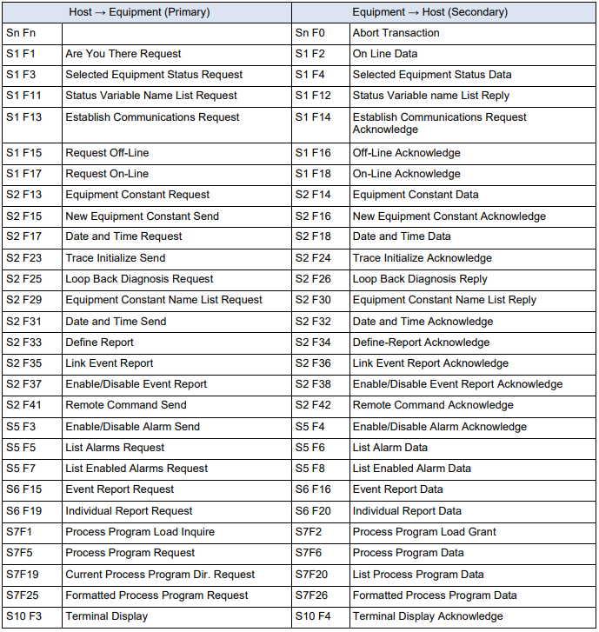

SECS-II Message List (E -> H)

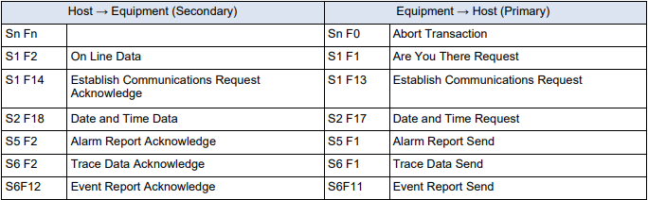

SECS-II Message Example
(Host perspective)

S1F1 : Are You There (H -> E)

Description :
The host may send this message to the EQ at any time. EQ sends this message periodically as a “heartbeat” to determine if the SECS link is alive.

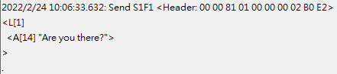

S1F2 : On-Line Data (E -> H)

Description :
EQ reports its Model Number and Software Revision to Host

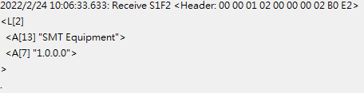

.
S1F3 : Selected Status Request (H -> E)

Description :
A request to EQ to report selected values of its status.

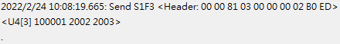

S1F4 : Selected Status Data (E -> H)

Description :
The equipment reports the value of each SVID requested in the order requested.

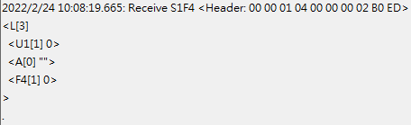

S1F11 : Status Variable NamelistRequest (H -> E)

Description :
A request to the equipment to identify certain status variables.

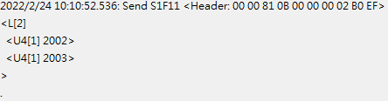

S1F12 : Status Variable Namelist Reply (E -> H)

Description :
EQ reports to the Host the name and units of the requested SVs.

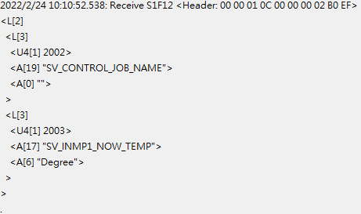

S1F13 : Establish Communication Request (H -> E)

Description:
Either end of the link may send S1F13 as the first message to establish connection of the link. Under EQ’s initialization logic, EQ will always attempt to establish the link. If no Host acceptance reply is received. EQ sends this message periodically.

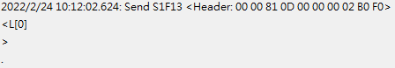

S1F14 : Establish Communication Request Acknowledge (E -> H)

Description:
Accept or deny Establish Communication Request.

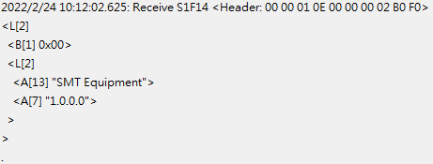

S1F15 : Request Off-Line (H -> E)

Description:
Host requests EQ to go Off-Line

S1F16 : Off-Line Acknowledge (E -> H)

Description:
EQ control state transits to Host Off-Line and sends this message in response to S1F15 primary.

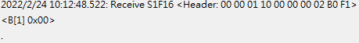

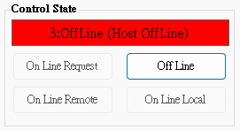

S1F17 : Request On-Line (H -> E)

Description:
Host requests EQ to go On-Line

S1F18 : On-Line Acknowledge (E -> H)

Description:
EQ responds to S1F17 primary in an attempt to go On-Line. Data item ONLACK indicates the success of failure of the attempt.

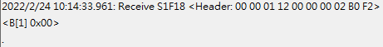

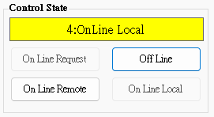

S2F13 : Equipment Constant Request (H -> E)

Description:
Constants and other values that are changed infrequently can be obtained using this message.

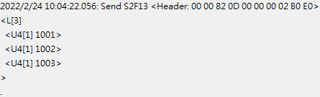

S2F14 : Equipment Constant Data (E -> H)

Description:
EQ returns constant data in the order requested in S2F13.

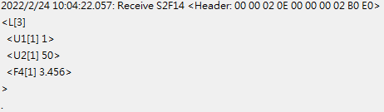

S2F15 : New Equipment Constant Send (H -> E)

Description:
Change one or more equipment constants.

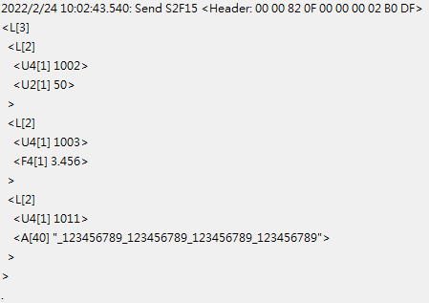

S2F16 : Equipment Constant Send Acknowledge (E -> H)

Description:
Change one or more equipment constants.

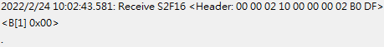

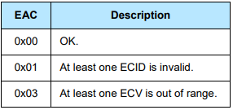

S2F17 : Date and Time Request (H -> E)

Description:
Host sends this message at any time to determine the date and time base EQ is currently using.

S2F18 : Date and Time Data (E -> H)

Description:
Host sends this message at any time to determine the date and time base EQ is currently using.

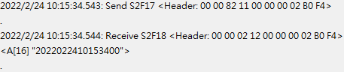

S2F23 : Trace Initialize Send (H -> E)

Description:
Trace initial send to device to enable/disable trace initial data. The trace data is returned on (S6F1) and is related to the original request by the TRID.

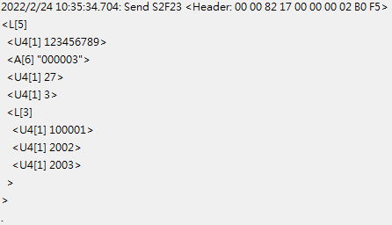

S2F24 : Trace Initialize Acknowledge (E -> H)

Description:
Acknowledge or error for Trace Initialize Send(S2F23)

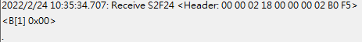

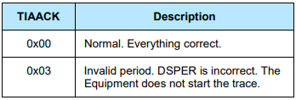

S2F25 : Diagnostic Loopback Request (H -> E)

Description:
Host sends an arbitrary binary string to test operation of the link.

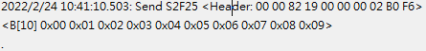

S2F26 Diagnostic Loopback Data (E -> H)

Description:
EQ “echoes” back the binary data from Host’s S2F25.

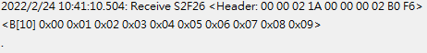

S2F29 Equipment Constant Namelist Request (H -> E)

Description:
This function allows the host to retrieve basic information about what equipment constants are available in the equipment.

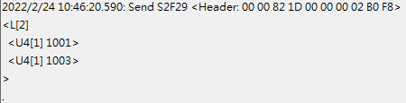

S2F30 : Equipment Constant Namelist Reply (E -> H)

Description:
Data Response for Equipment Constant Namelist Request(S2F29).

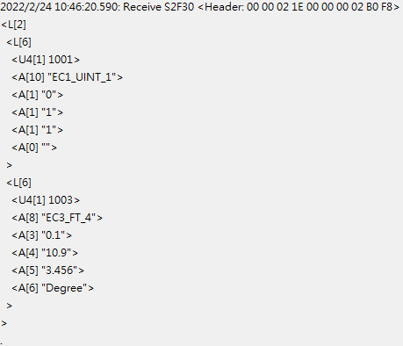

S2F31 : Date and Time Send (H -> E)

Description:
Useful to synchronize the equipment time with the host time base.

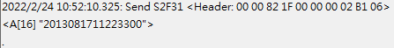

S2F32 Date and Time Acknowledge (E -> H)

Description:
Acknowledge the receipt of time and date.

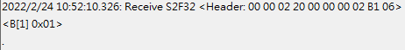

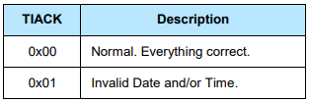

S2F33 Define Report (H -> E)

Description:
The purpose of this message is for the host to define a group of reports for the equipment. The event report will be sent via S6F11 when the event occurred.

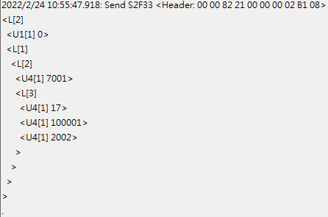

S2F34 Define Report Acknowledge (E -> H)

Description:
Acknowledge or error if an error condition is detected the entire message is rejected(i.e., partial changes are not allowed)

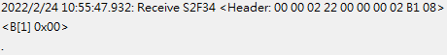

S2F35 : Link Event Report (H -> E)

Description:
The purpose of this message is for the host to link n reports to an event(CEID). These linked event reports will default to ‘disabled’ upon linking. That is, the occurrence of an event would not cause the report to be sent until enabled. See S2F37 for enabling reports.

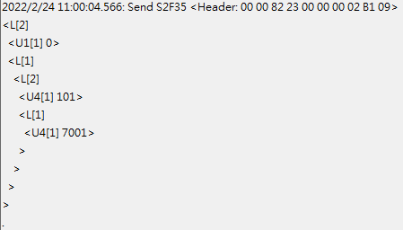

S2F36 Link Event Report Acknowledge (E -> H)

Description:
Acknowledge or error if an error condition is detected the entire message is rejected(i.e., partial changes are not allowed).

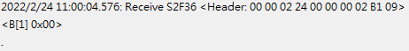

S2F37 : Enable/Disable Event Report (H -> E)

Description:
The purpose of this message is for the host to enable or disable reporting for a group of events(CEIDs).

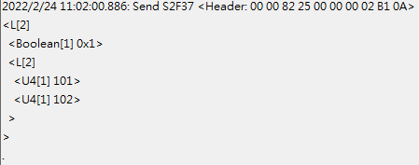

S2F38 : Enable/Disable Event Report Acknowledge (E -> H)

Description:
Acknowledge or error if an error condition is detected the entire message is rejected(i.e., partial changes are not allowed).

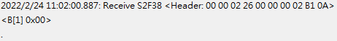

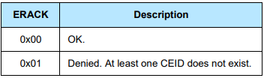

S2F41 : Remote Command Send (H -> E)

Description:
The host requests the equipment perform the specified remote command with the associated parameters.

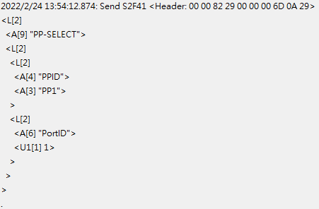

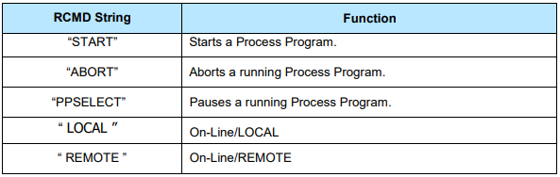

S2F42 : Remote Command Acknowledge (E -> H)

Description:
Acknowledge host’s command or error. If command is not accepted due to one or more invalid parameters, then a list of invalid parameters will be returned containing the parameter name and reason for being invalid.

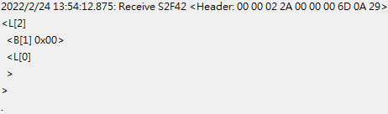

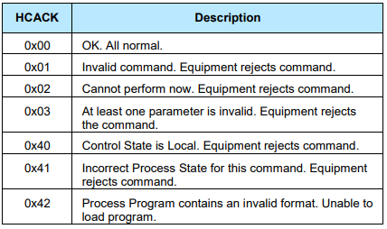

S5F1 : Alarm Report (E -> H)

Description:
This message reports a change in or presence of an alarm condition. One message will be issued when the alam is set and one message will be issued when the alarm is cleared. Irrecoverable errors and attention flags may not have a corresponding clear message.

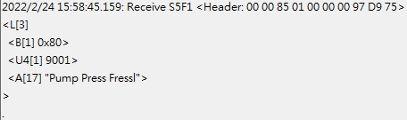

S5F2 : Alarm Acknowledge (H -> E)

Description:
The host acknowledges the alarm report. This equipment ignores the ACKC5.

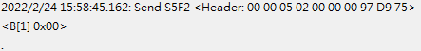

S5F3 Enable/Disable Alarm Send (H -> E)

Description:
This message will change the state of the enable bit in the equipment. The enable bit determines if the alarm will be sent to the host. Alarms which are not controllable in this way are unaffected by this message.

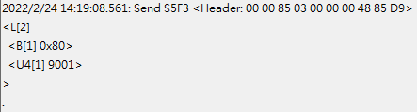

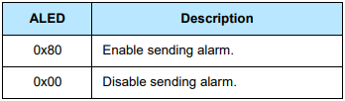

S5F4 Enable/Disable Alarm Acknowledge (E -> H)

Description:
The host acknowledges the alarm report. This equipment ignores the ACKC5.

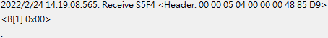

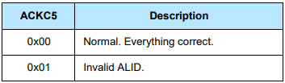

S5F5 : List Alarms Request (H -> E)

Description:
This message requests the equipment to send binary and analog alarm information to the host.

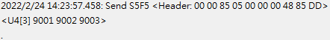

S5F6 : List Alarm Data (E -> H)

Description:
This message contains the alarm data known to the equipment.

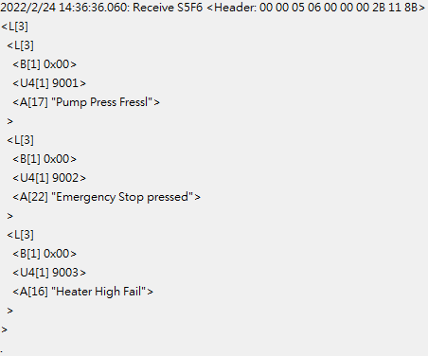

S5F7 : List Enabled Alarms Request (H -> E)

Description:
List all alarms which are enabled .

S5F8 : List Enabled Alarm Data (E -> H)

Description:
This message is similar to S5F6 except that it lists only alarms which are enabled.

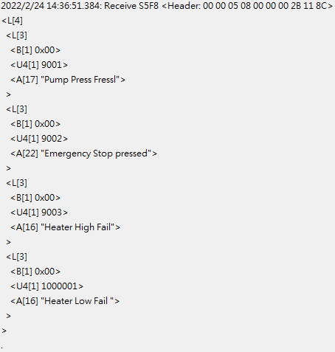

S6F1 : Trace Data Send (E -> H)

Description:
This function sends samples to the host according to the trace setup done by S2F23. Trace is a time-driven form of equipment status.

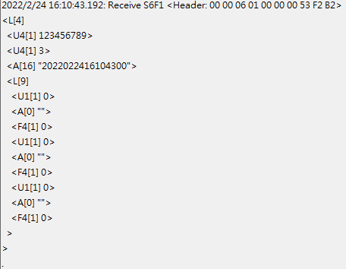

S6F2 : Trace Data Acknowledge (H -> E)

Description:
List all alarms which are enabled .

S6F11 : Event Report Send (E -> H)

Description:
The purpose of this message is for the equipment to send a defined, linked, and enabled group of reports to the host upon the occurrence of an event(CEID).

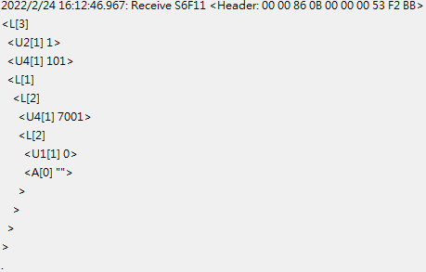

S6F12 : Event Report Acknowledge (H -> E)

Description:
Acknowledge or error for Event Report Send(S6F11).

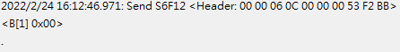

S6F15 : Event Report Request (H -> E)

Description:
The purpose of this message is for the host to demand a given report group form the equipment.

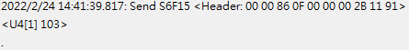

S6F16 : Event Report Data (E -> H)

Description:
EQ sends reports linked to given CEID to host.

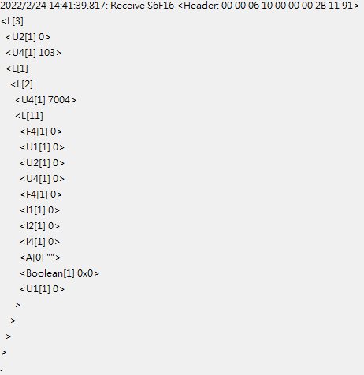

S6F19 : Individual Report Request (H -> E)

Description:
Host requests a Report for the specified RPTID.

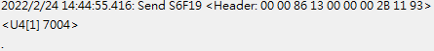

S6F20 : Individual Report Data Event Report Data (E -> H)

Description:
EQ sends variable data defined for the given to the host.

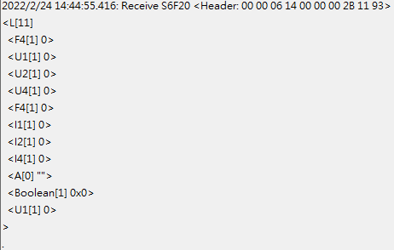

S7F1 : Process Program Load Inquire (H -> E)

Description:
The sender requests permission to send a process program.

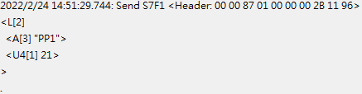

S7F2 : Process Program Load Grant (E -> H)

Description:
The receiver grants permission to send a process program.

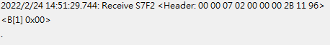

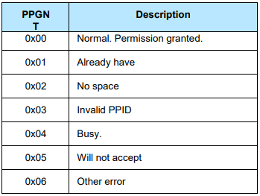

S7F5 : Process Program Request (H -> E)

Description:
Request the other end of the link to send a specified process program from its library.

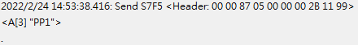

S7F6 : Process Program Data (E -> H)

Description:
Send the requested process program.

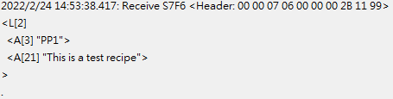

S7F19 : Process Program Dir. Request (H -> E)

Description:
The host requests a directory of the process program currently in the EQ’s library.

S7F20 : Current Process Program Data (E -> H)

Description:
The EQ sends a directory of its process program library. If the library is empty, the list will be zero length.

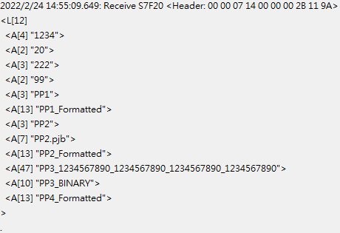

S7F25 : Formatted Process Program Request (H -> E)

Description:
The host requests a process program currently in the EQ’s library.

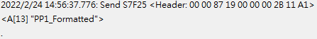

S7F26 : Formatted Process Program Data (E -> H)

Description:
The EQ sends a formatted process program data to the host.

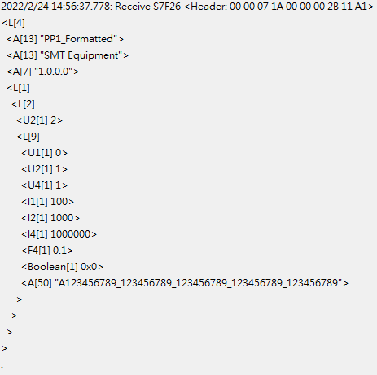

S9F7 : Invalid Data

Description:
This message indicates that the stream and function were recognized, but the associated data format could not be interpreted.

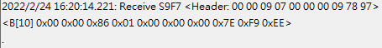

S9F9 : Transaction Timer Timeout

Description:
This message indicates that a transaction (receive) timer has timed out and that the corresponding transaction has been aborted. It is up to the host to respond to this error in an appropriate manner to keep the system operational.

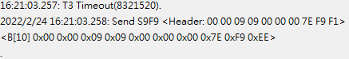

S10F1 : Terminal Request

Description:
A terminal text message to the host.

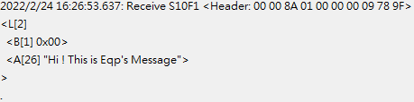

S10F2 : Terminal Request Acknowledge

Description:
Acknowledge or error for terminal request (S10F1).

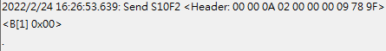

S10F3 : Terminal Display, Single (H -> E)

Description:
Data to be displayed.

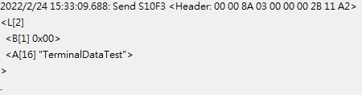

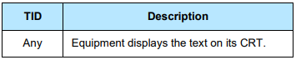
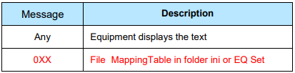

S10F4 : Terminal Request Acknowledge (E -> H)

Description:
Acknowledge or error for terminal request (S10F3).

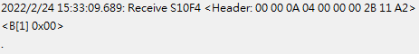

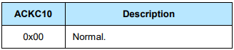

PPBODY – AOI

ID | Name | Enable | Unit | Format | Min | Max | Explanation
101 | AOI_CornerA_X | TRUE | mm | ASCII | 0 | 500 | Boat A角落的X位置
102 | AOI_CornerA_Y | TRUE | mm | ASCII | 0 | 500 | Boat A角落的Y位置
103 | AOI_CornerC_X | TRUE | mm | ASCII | 0 | 500 | Boat C角落的X位置
104 | AOI_CornerC_Y | TRUE | mm | ASCII | 0 | 500 | Boat C角落的Y位置
114 | AOI_Substrate_Row | TRUE | Number | ASCII | 1 | 2 | 產品參數
115 | AOI_Substrate_Col | TRUE | Number | ASCII | 1 | 1 | 產品參數
116 | AOI_Block_Row | TRUE | Number | ASCII | 1 | 4 | 產品參數
117 | AOI_Block_Col | TRUE | Number | ASCII | 1 | 4 | 產品參數
118 | AOI_Unit_Row | TRUE | Number | ASCII | 2 | 20 | 產品參數
119 | AOI_Unit_Col | TRUE | Number | ASCII | 2 | 20 | 產品參數
120 | AOI_Boat_Left_Offset | TRUE | pixel | ASCII | 0 | 3500 | Boat偏移量
121 | AOI_Boat_Right_Offset | TRUE | pixel | ASCII | 0 | 3500 | Boat偏移量
122 | AOI_Boat_Top_Offset | TRUE | pixel | ASCII | 0 | 2500 | Boat偏移量
123 | AOI_Boat_Bottom_Offset | TRUE | pixel | ASCII | 0 | 2500 | Boat偏移量

PPBODY - Sorter

ID | Name | Enable | Unit | Format | Min | Max | Explanation
201 | Sorter_Recipe_Name | TRUE | Null | A |  |  | Recipe名稱
202 | Sorter_Recipe_ProductName | TRUE | Null | A |  |  | 產品名稱
203 | Sorter_Recipe_X_Num | TRUE | Number | A | 1 | 20 | 橫向料數
204 | Sorter_Recipe_Y_Num | TRUE | Number | A | 1 | 10 | 縱向料數
205 | Sorter_Recipe_Board1_P1_X | TRUE | mm | A | 41000 | 42500 | NG區軌道P1點X
206 | Sorter_Recipe_Board1_P1_Y | TRUE | mm | A | 551500 | 552500 | NG區軌道P1點Y
207 | Sorter_Recipe_Board1_P1_Z | TRUE | mm | A | 73500 | 74500 | NG區軌道P1點Z
208 | Sorter_Recipe_Board1_P4_X | TRUE | mm | A | 311000 | 312000 | NG區軌道P4點X
209 | Sorter_Recipe_Board1_P4_Y | TRUE | mm | A | 672000 | 673000 | NG區軌道P4點Y
210 | Sorter_Recipe_Board1_P4_Z | TRUE | mm | A | 73500 | 74500 | NG區軌道P4點Z
211 | Sorter_Recipe_Board2_P1_X | TRUE | mm | A | 41000 | 42500 | OK區軌道P1點X
212 | Sorter_Recipe_Board2_P1_Y | TRUE | mm | A | 325500 | 327500 | OK區軌道P1點Y
213 | Sorter_Recipe_Board2_P1_Z | TRUE | mm | A | 73500 | 74500 | OK區軌道P1點Z
214 | Sorter_Recipe_Board2_P4_X | TRUE | mm | A | 311000 | 312000 | OK區軌道P4點X
215 | Sorter_Recipe_Board2_P4_Y | TRUE | mm | A | 445500 | 447500 | OK區軌道P4點Y
216 | Sorter_Recipe_Board2_P4_Z | TRUE | mm | A | 73500 | 74500 | OK區軌道P4點Z
217 | Sorter_Recipe_Board3_P1_X | TRUE | mm | A | 41000 | 42500 | ST區軌道P1點X
218 | Sorter_Recipe_Board3_P1_Y | TRUE | mm | A | 99000 | 101000 | ST區軌道P1點Y
219 | Sorter_Recipe_Board3_P1_Z | TRUE | mm | A | 73500 | 74500 | ST區軌道P1點Z
220 | Sorter_Recipe_Board3_P4_X | TRUE | mm | A | 311000 | 313000 | ST區軌道P4點X
221 | Sorter_Recipe_Board3_P4_Y | TRUE | mm | A | 220000 | 221000 | ST區軌道P4點Y
222 | Sorter_Recipe_Board3_P4_Z | TRUE | mm | A | 73500 | 74500 | ST區軌道P4點Z
223 | Sorter_Recipe_Zdown_Position | TRUE | mm | A | 80000 | 90000 | 下壓高度

MAGAZINE MOVEIN LOG

Description:
MagazineID attached to the MagazineMoveInEvent(101).

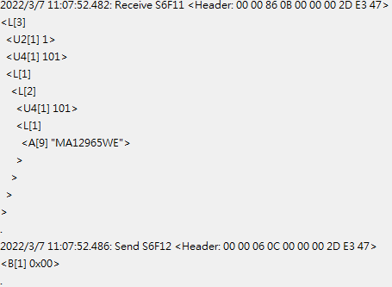
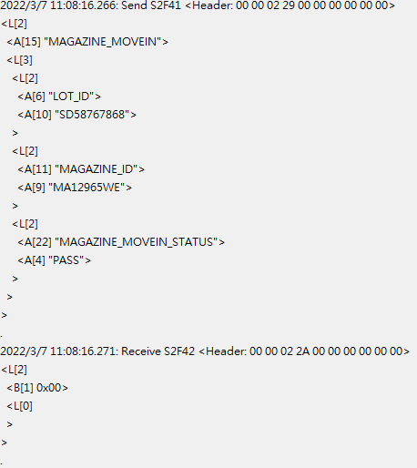

※Please return “PASS” or “NG” with MAGAZINE_MOVEIN_STATUS
BOAT MOVEIN LOG

Description:
BoatBarcode attached to the BoatMoveInEvent(102).

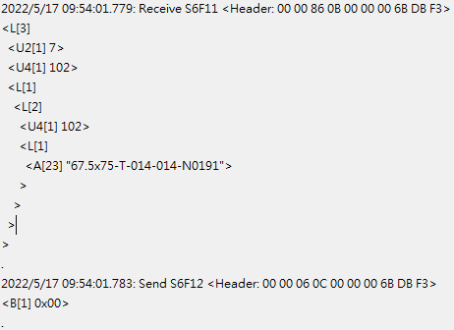
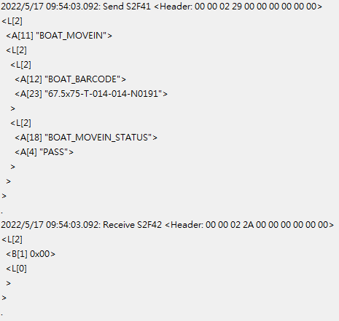

※Please return “PASS” or “NG” with BOAT_MOVEIN_STATUS

PASSBOAT MOVEOUT LOG

Description:
PassBoatBarcode attached to the PassBoatMoveOutEvent(103).

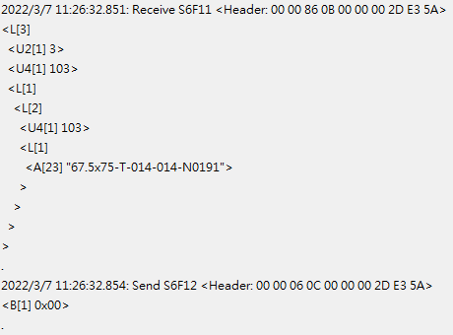

NGBOAT MOVEOUT LOG

Description:
NGBoatBarcode attached to the NGBoatMoveOutEvent(104).

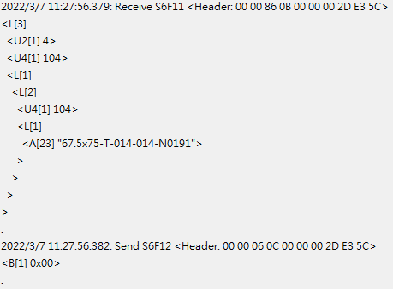

EMPTYBOAT RELEASE LOG

Description:
EmptyBoatBarcode attached to the EmptyBoatReleaseEvent(105).

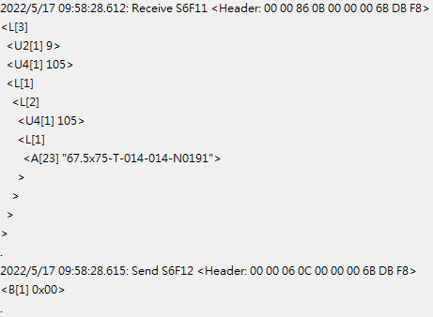
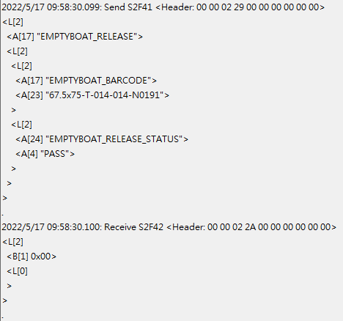

※Please return “PASS” or “NG” with EMPTYBOAT_RELEASE_STATUS

PASS1MAGAZINE MOVEIN LOG

Description:
Pass1MagazineID attached to the Pass1MagazineMoveInEvent(106).

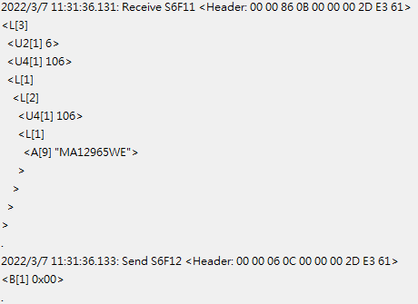
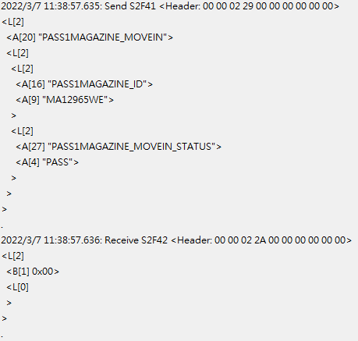

※Please return “PASS” or “NG” with PASS1MAGAZINE_MOVEIN_STATUS
PASS2MAGAZINE MOVEIN LOG

Description:
Pass2MagazineID attached to the Pass2MagazineMoveInEvent(107).

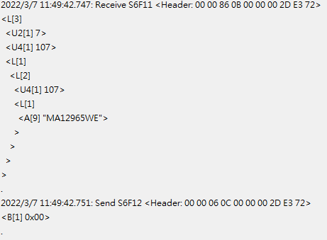
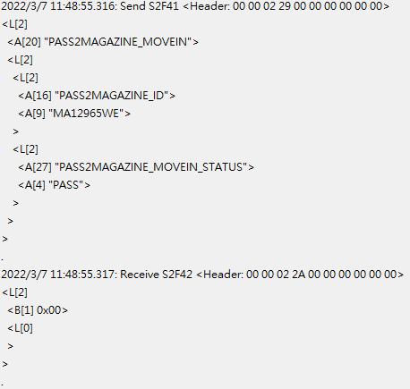

※Please return “PASS” or “NG” with PASS2MAGAZINE_MOVEIN_STATUS
NGMAGAZINE MOVEIN LOG

Description:
NGMagazineID attached to the NGMagazineMoveInEvent(108).

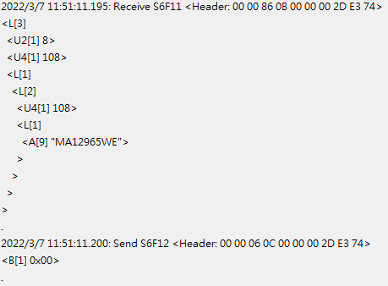
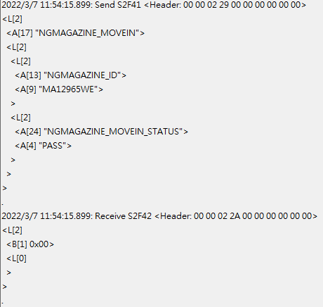

※Please return “PASS” or “NG” with NGMAGAZINE_MOVEIN_STATUS
EMPTYMAGAZINE MOVEIN LOG

Description:
EmptyMagazineID attached to the EmptyMagazineMoveInEvent(109).

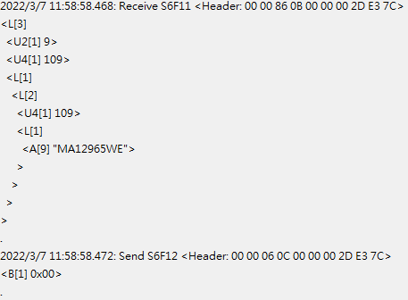
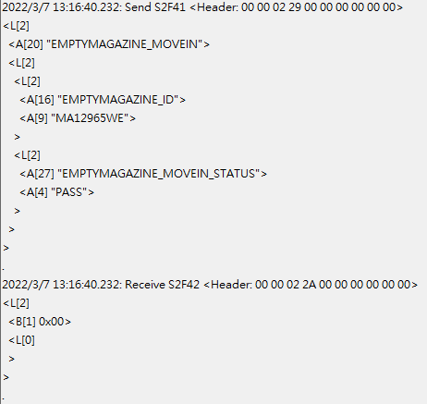

※Please return “PASS” or “NG” with EMPTYMAGAZINE_MOVEIN_STATUS
PASS1MAGAZINE MOVEOUT LOG

Description:
Pass1MagazineID attached to the Pass1MagazineMoveOutEvent(110).

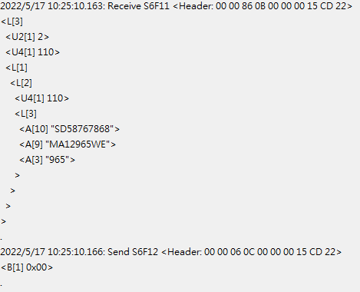
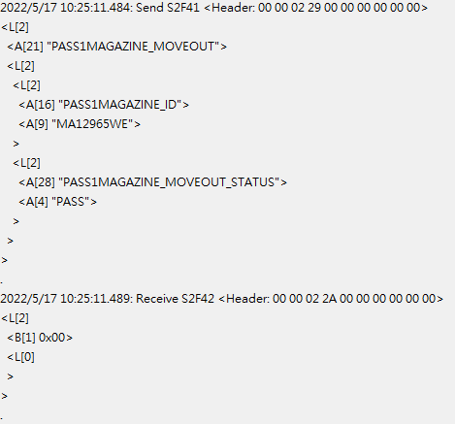

※Please return “PASS” or “NG” with PASS1MAGAZINE_MOVEOUT_STATUS
PASS2MAGAZINE MOVEOUT LOG

Description:
Pass2MagazineID attached to the Pass2MagazineMoveOutEvent(111).

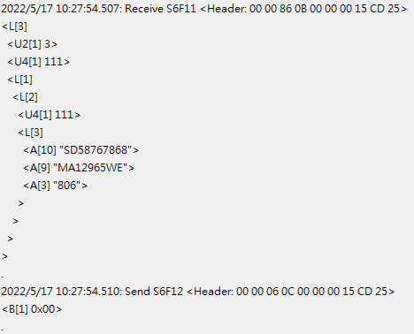
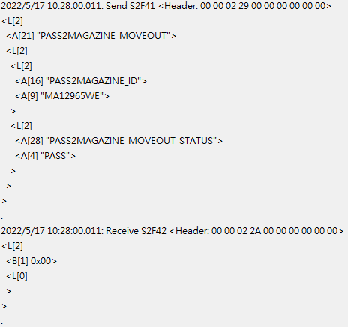

※Please return “PASS” or “NG” with PASS2MAGAZINE_MOVEOUT_STATUS
NGMAGAZINE MOVEOUT LOG

Description:
NGMagazineID attached to the NGMagazineMoveOutEvent(112).

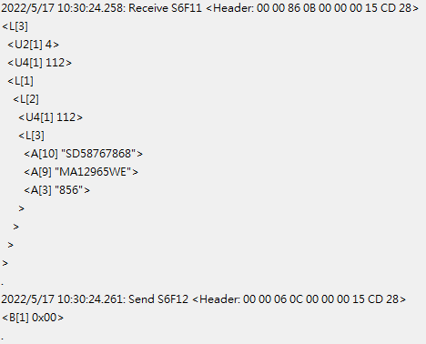
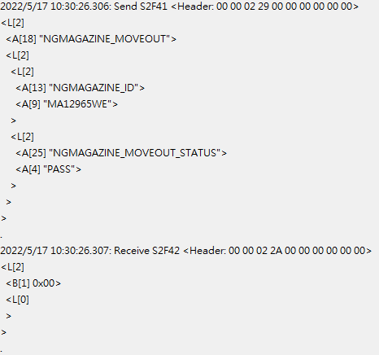

※Please return “PASS” or “NG” with NGMAGAZINE_MOVEOUT_STATUS
BOAT ASSING NGBOAT LOG

Description:
BoatAssingNGBoatBarcode attached to the BoatAssingNGBoatEvent(113).

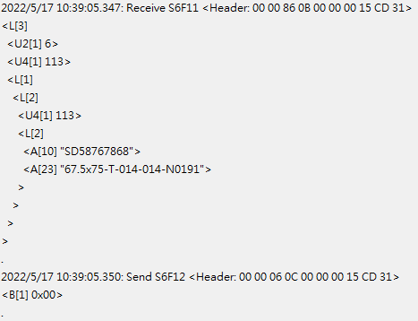
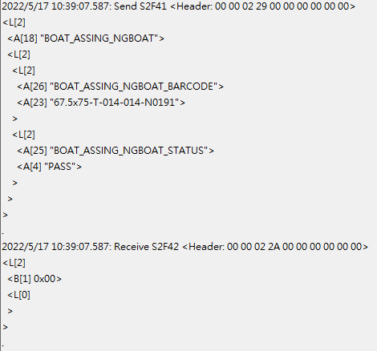

※Please return “PASS” or “NG” with BOAT_ASSING_NGBOAT_STATUS
UI LOCK COMMAND LOG

Description:
UI Lock state switched result attached to the RemoteActionResultEvent(114).

★Remote control UI lock log. (SUCCESS or FAIL)
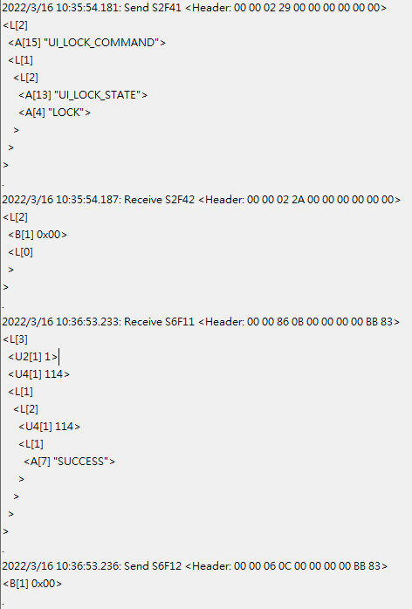
★Remote control UI unlock log. (SUCCESS or FAIL)
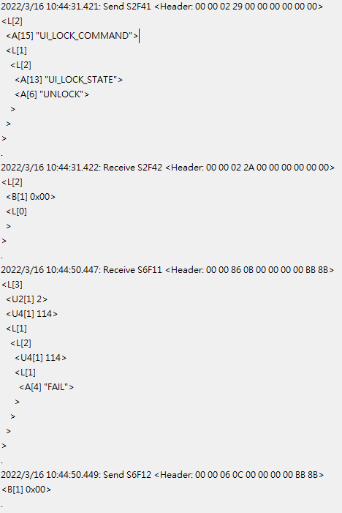

EQUIPMENT OPERATIONAL COMMAND LOG

Description:
Equipment Operational state switched result attached to the RemoteActionResultEvent(114).

★Remote control equipment start log. (SUCCESS or FAIL)
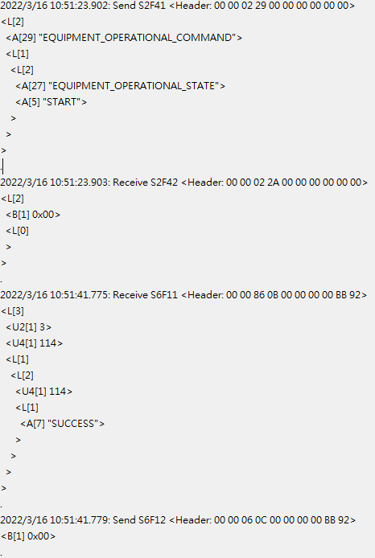

★Remote control equipment stop log. (SUCCESS or FAIL)
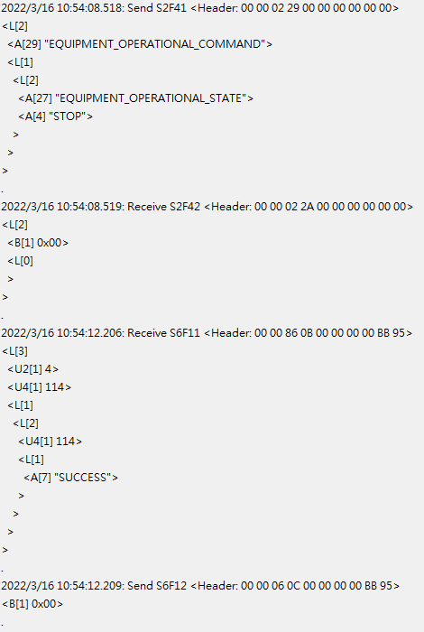

EQUIPMENT ENDLOT COMMAND LOG

Description:
Equipment endlot result attached to the RemoteActionResultEvent(114).

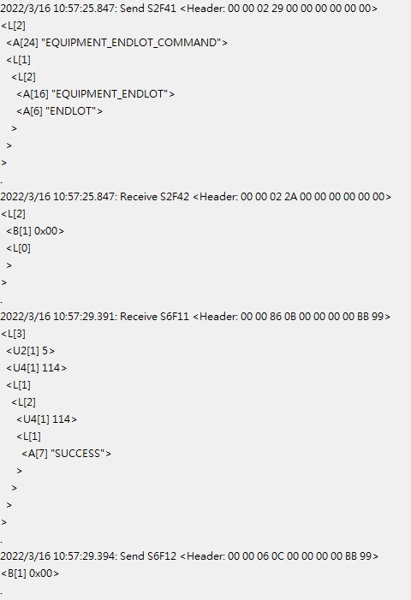
EQUIPMENT STARTRUN CHECK LOG

Description:
RecipeName attached to the EquipmentStartRunEvent(115).

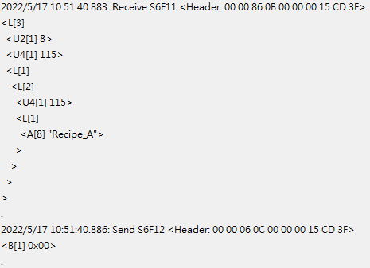
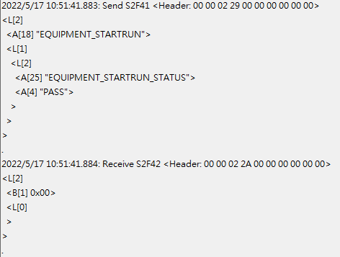

※Please return “PASS” or “NG” with EQUIPMENT_STARTRUN_STATUS

